- Complete the sentences with these prepositions.

- We wanted to have something different to eat but we ended ____________ with pizza as usual.
- Our teacher is very hard ___________ students who do not do their homework.
- I left my dog ___________ his own for the afternoon while I went shopping.
- I always feel guilty __________ buying chocolates!
- My brother is really good ________ running.
- My mother always says she won’t let us have any more fast food but she always gives in?
- Every time I go to the café with Robbie I end up paying _______ the drinks.
- We often invite friends’ __________ to watch a DVD.

- Match these statements with the picture.
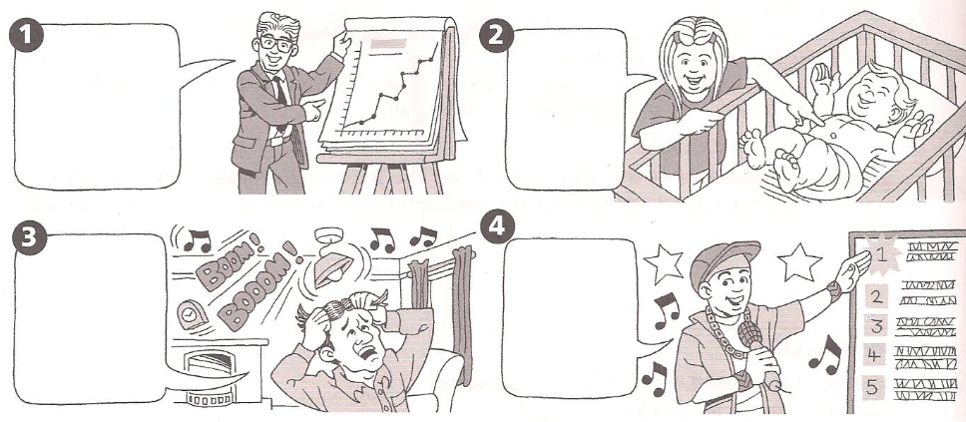
- _______________________
- _______________________
- _______________________
- _______________________

- Who says these things? Circle S for Sadie, M for Maria, T for Ted. Sometimes you need to circle more than one.

Listen to this conversation
- Older people do not like it.
- There have been strange records before.
- It is a wonderful song.
- You hear it everywhere.
- The frog is the wrong color.
- Pop music is not for adults.
- I do not want to listen to it.
S | M | T
S | M | T
S | M |  | T
S | M |  | T
S | M |  | T
S | M |  | T
S | M |  | T

- Listen again to the radio program. Write sentences or phrases that you listen from each person:

Person | Phrases or sentences
Sadie
Maria
Ted

